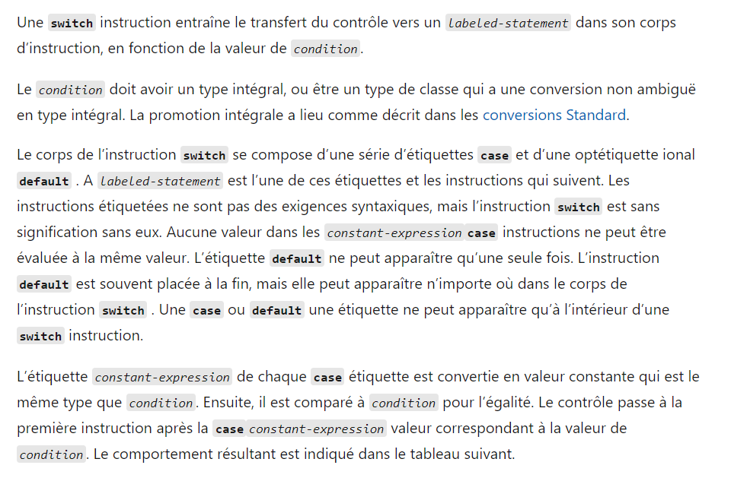

<https://learn.microsoft.com/fr-fr/cpp/cpp/switch-statement-cpp?view=msvc-170>

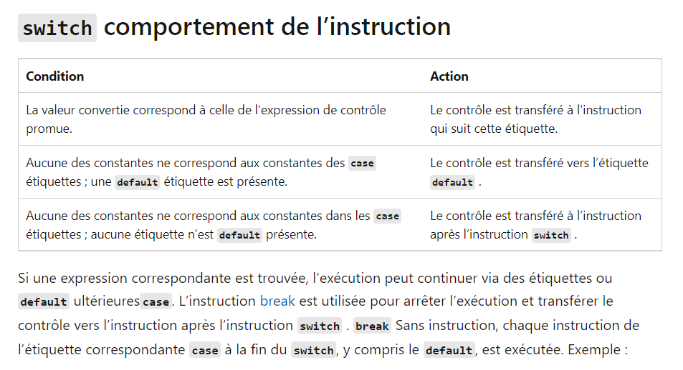

Cin ~ Serial.read

Cout ~ Serial.println